Sn1 or Sn2 Reactions: A Guide to Deciding Which Reaction is Occurring

The following is a discussion of the approach you should use in order to determine if a chemical reaction occurs via a Sn1 or Sn2 mechanism.

This approach involves systematically analyzing all aspects of the reaction, then coming up with a decision based upon what you know. You should analyze the following aspects of each reaction, in the order introduced below.

STEP 1: THE STRUCTURE OF THE SUBSTRATE

- Remember: the structure of the substrate is a very important consideration in determining if a reaction occurs by an Sn1 or Sn2 mechanism.

- What is the structure of the substrate? Determine this.

- Remember the trend of substrate reactivity for Sn1 & Sn2:

  - Sn1: 3º > 2º > 1º > methyl
  - Sn2: methyl > 1º > 2º > 3º

- If your substrate is tertiary (3º ): Sn1 highly favored. It won’t go by Sn2.

- If your substrate is secondary (2º ): Not the best substrate for Sn1, but it still is ok. Not the best for Sn2 also, but it could still go by this mechanism. In other words, it could go either way, so you must look at other factors before making your decision.

- If your substrate is primary (1º ): Sn2 favored. It won’t go by Sn1.

- If your substrate is methyl: Sn2 highly favored. It won’t go by Sn1.

STEP 2: THE NATURE OF THE NUCLEOPHILE

- Is the nucleophile strong or weak? (alternate: good or bad).

- Sn2 reactions favor strong nucleophiles.

- Sn1 reactions favor weak nucleophiles.

- What makes a nucleophile strong?

  - Negative charge:
    - A negatively charged species is a better nucleophile than a similar, uncharged species. In particular, a base is a stronger nucleophile than its conjugate acid.
  - Electronegativity:
    - Nucleophilicity decreases from right to left on the periodic table, following the increase in electronegativity.
  - Size and Polarizability:
    - Nucleophilicity increases down a group on the periodic table, following the increase in size and polarizability.

- What makes a nucleophile weak?
  - Neutral charge

- Remember sterics!
    - Bulky nucleophiles slow down reaction rates

STEP 3: NATURE OF THE LEAVING GROUP

- Sn1 and Sn2 reactions favor good leaving groups. Therefore, this aspect really not a major factor in deciding if a reaction follows a Sn1 or Sn2 mechanism.

- HOWEVER: the nature of the leaving group plays an important role in determining if a reaction will undergo a substitution reaction at all!

- What is a good leaving group?

  - Electron withdrawing, to polarize the carbon atom on the substrate
  - stable (not a strong base) once it has left
  - polarizable (able to stabilize the transition state)

- Weak bases that are common, good leaving groups:
  - Cl ⁻ , Br ⁻, I –
  - Sulfonate, sulfate, phosphate (see your notes)
  - neutral molecules:
    - H₂O
    - Alcohols (R-OH)
    - Amines (R₃N)
    - Phosphines (R₃P)

- THE FOLLOWING ARE NEVER LEAVING GROUPS:
  - Hydroxide (OH⁻)
  - Alkoxide (RO⁻), like CH₃CH₂O⁻
  - Amide (NH₂⁻)

STEP 4: THE NATURE OF THE SOLVENT

- Solvent does play a role in determining whether a reaction goes by a Sn1 or Sn2 mechanism. However, it is typically not a major role…but it can “tip the scales” in the favor of one mechanism depending on the nature of the nucleophile and the substrate.

- Polar protic solvents:

  - Have acidic hydrogens
  - Very strong solvating power
  - Very good for Sn1 reactions.
  - Examples: water, alcohols

- Polar aprotic solvents:

  - Do not have acidic hydrogens
  - Good solvating power, but not as strong as polar protic solvents.
  - Very good for Sn2 reactions.
  - Examples: acetone, acetonitrile, dimethylformamide, crown ethers

- Aprotic solvents:

  - Non-polar solvents.
  - Not good for either Sn1 or Sn2.
  - Problem: nucleophiles not typically soluble in these solvents. Therefore, they are not really useful for substitution reactions.

STEP 5: PUTTING IT ALL TOGETHER

- Consider all your analyses.
- Remember, nature of nucleophile and structure of substrate are most important.
- Nature of leaving group less important, since good leaving groups are important for both mechanisms.
- Solvent not a major factor, but its identity (polar protic, polar aprotic, etc) can be a deciding factor in your decision.

WORKED EXAMPLES:

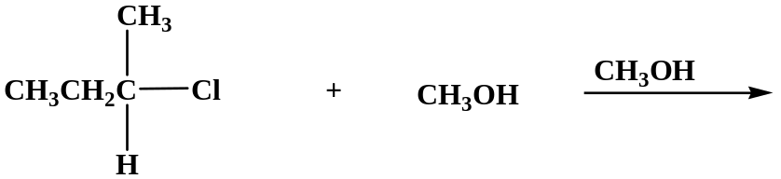
a)

Analysis:

1) Substrate: secondary. Can go either Sn1 or Sn2
2) Nucleophile: Weak nucleophile (it’s neutral).
3) Solvent: polar protic. Good for Sn1.
4) Leaving group: Cl, which is a good leaving group.

Decision:

Remember that substrate structure and the nucleophile play major roles in this decision. The substrate is secondary, which can go either Sn1 or Sn2. Therefore, you must consider other factors. The nucleophile is weak, which is good for Sn1. The solvent is polar protic, which is also good for Sn1. The leaving group is good, which doesn’t really matter here, but it does indicate that a substitution reaction (whichever mechanism) will occur.

Answer: Sn1 mechanism.

b)

Analysis:

1) Substrate: primary. Good for Sn2.
2) Nucleophile: OH⁻ , Strong nucleophile, good for Sn2.
3) Solvent: polar aprotic. Good for Sn2.
4) Leaving group: NH₂⁻ , which is an extremely bad leaving group.

Decision:

Everything points to a Sn2 mechanism until the leaving group is considered. In this case, the leaving group is very poor. Therefore, it is doubtful if this reaction will even work at all.

Answer: No reaction.

c)

Analysis:

1) Substrate: primary. Good for Sn2.
2) Nucleophile: OCH₃⁻ , Strong nucleophile, good for Sn2.
3) Solvent: polar aprotic. Good for Sn2.
4) Leaving group: I⁻, a very good leaving group.

Decision:

Classic example of an Sn2 reaction. Everything points to it.

Answer: Sn2 reaction.

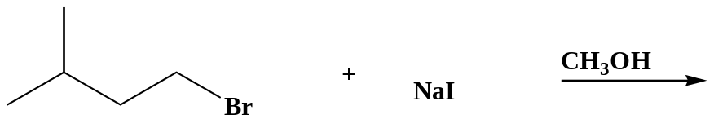
d)

Analysis:

1) Substrate: primary. Good for Sn2
2) Nucleophile: I⁻, Strong nucleophile, good for Sn2.
3) Solvent: polar protic. Good for Sn1, not the best for Sn2.
4) Leaving group: Br ⁻, a very good leaving group.

Decision:

The data suggests Sn2, except for the solvent. Methanol is a polar protic solvent, which is good for a Sn1 reaction. However, given the nature of the substrate and nucleophile (both good for Sn2), the solvent won’t be that important.

Answer: Sn2 reaction.

